Costa Rican Glass Compositions

Julie M. Coulombe

2/25/2020

An analysis of volcanic glass sampled from the Tajo La Florida quarry at Barva Volcano in Costa Rica. Samples collected are from potentially different lava flows. Data was acquired by using an electron microprobe.

Data points were constrained as follows:

Wt% Totals > 95.0 and < 101.0  
SiO2 < 90.0  
Al2O3 > 10.0 and < 22.0  
K2O > 1.0

Create plot for SiO2 vs Na2O + K2O by each rock

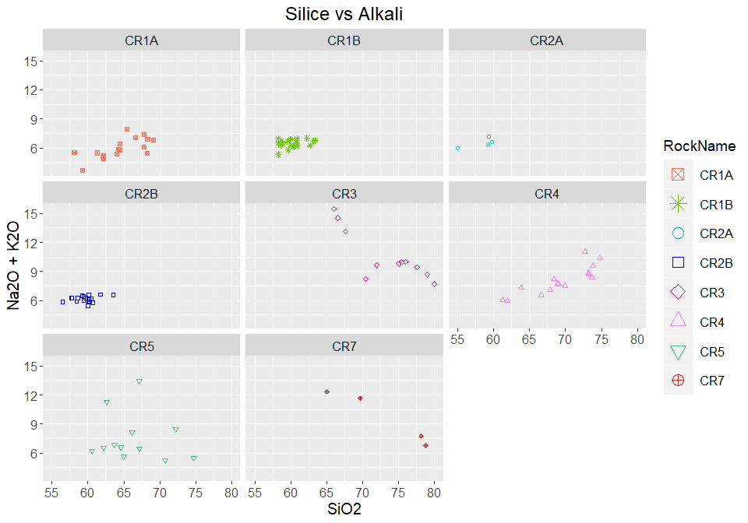

Create plot for SiO2 vs Mg# by each rock

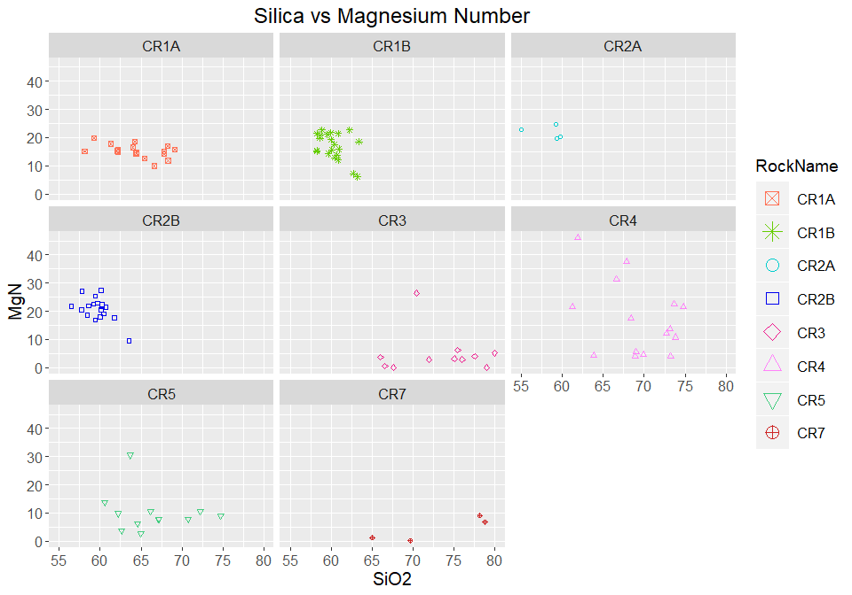

Create plot for SiO2 vs FeO by each rock

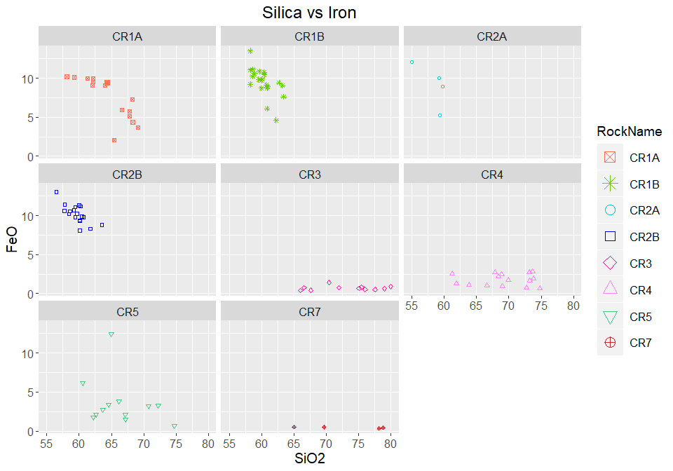

Create plot for Al2O3 vs TiO by each rock

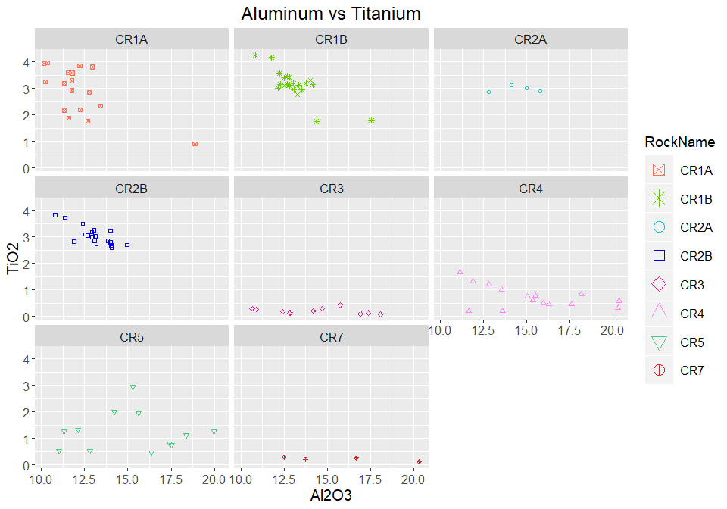

##Create TAS template

Plot Alkali by Rock Name

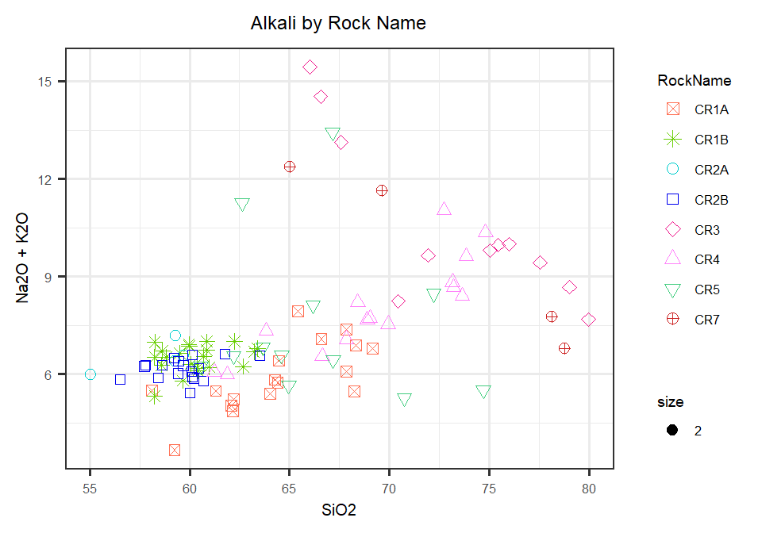

Overlay Alkali Plot on TAS Diagram 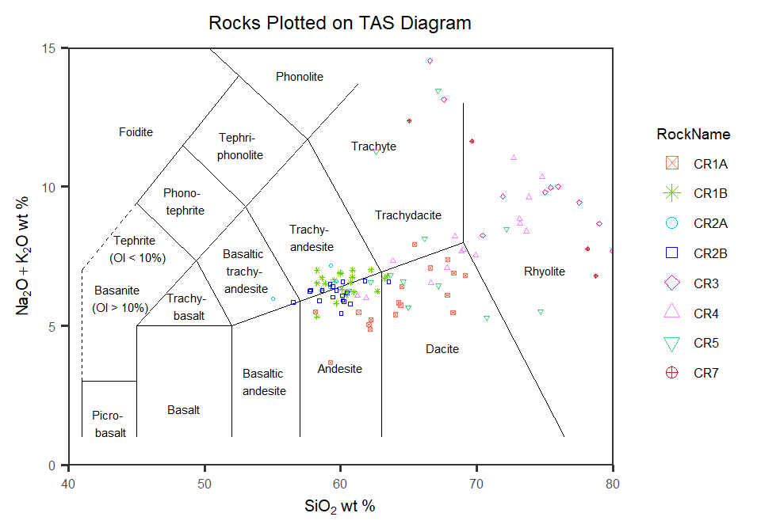

Now to look at plots of all rocks together

Plot Silica vs Mg# by rock

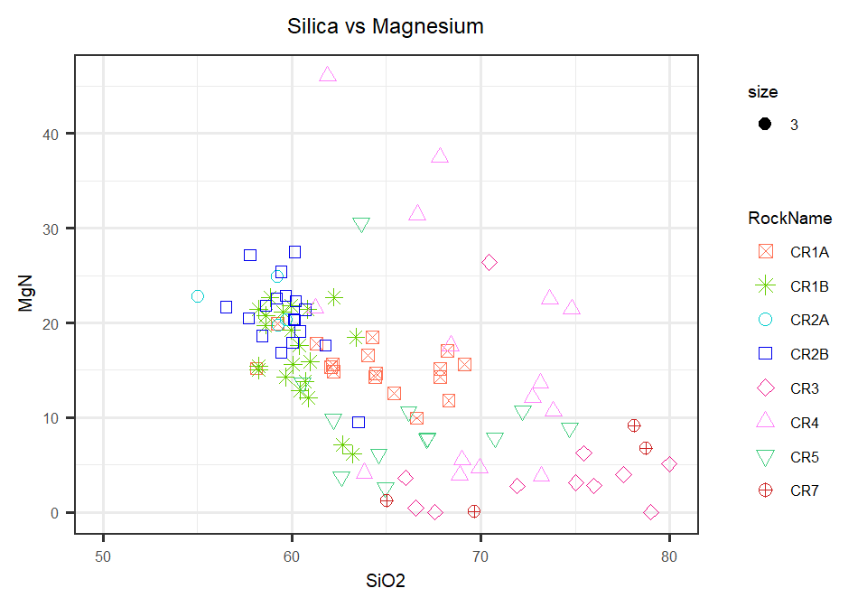

Plot Silica vs Iron by rock

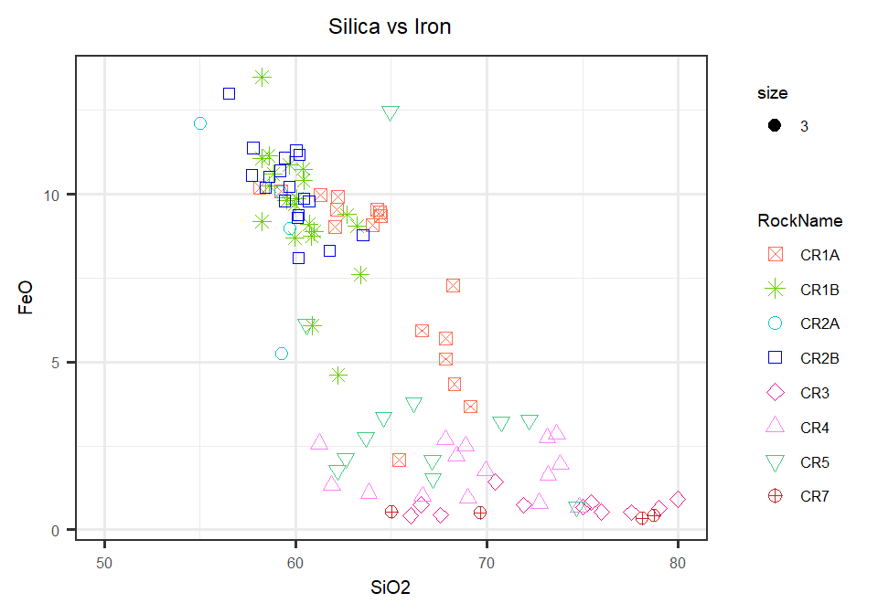

Plot Aluminum vs Titanium by rock

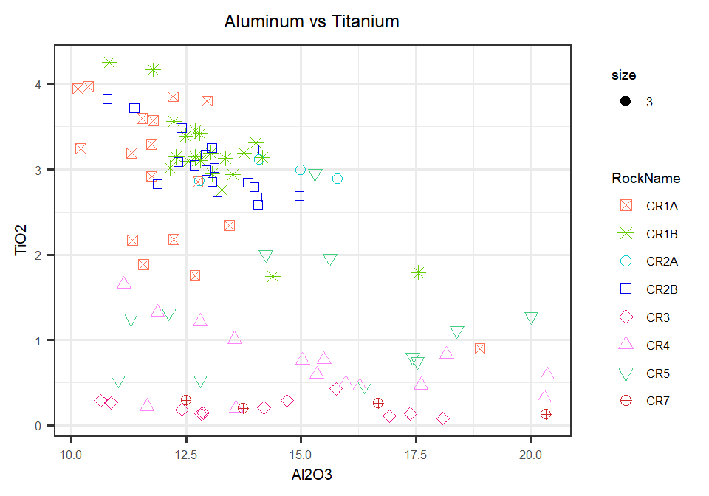

A table comparing mean and standard deviation of Aluminum and Titanium

|  |  |  |  |  |
| --- | --- | --- | --- | --- |
| **RockName** | **Al2O3mn** | **Al2O3sd** | **TiO2mn** | **TiO2sd** |
| CR1A | 12.174 | 1.964 | 2.910 | 0.899 |
| CR1B | 13.117 | 1.314 | 3.139 | 0.581 |
| CR2A | 14.424 | 1.282 | 2.965 | 0.115 |
| CR2B | 13.036 | 1.042 | 3.047 | 0.353 |
| CR3 | 14.239 | 2.563 | 0.206 | 0.104 |
| CR4 | 15.275 | 2.924 | 0.729 | 0.421 |
| CR5 | 15.177 | 2.920 | 1.247 | 0.744 |
| CR7 | 15.810 | 3.481 | 0.219 | 0.072 |

Taking a look at comparing CR1A to CR1B (two samples from the same flow)

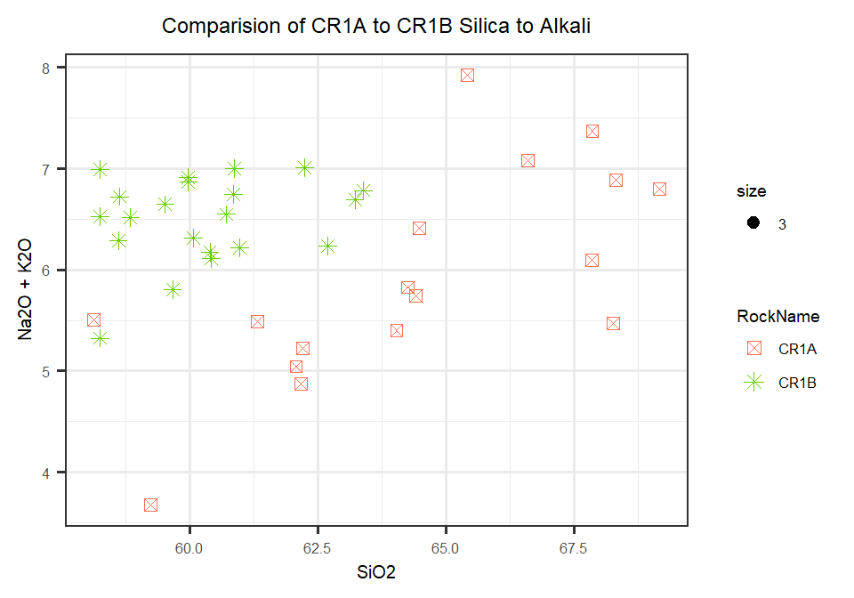

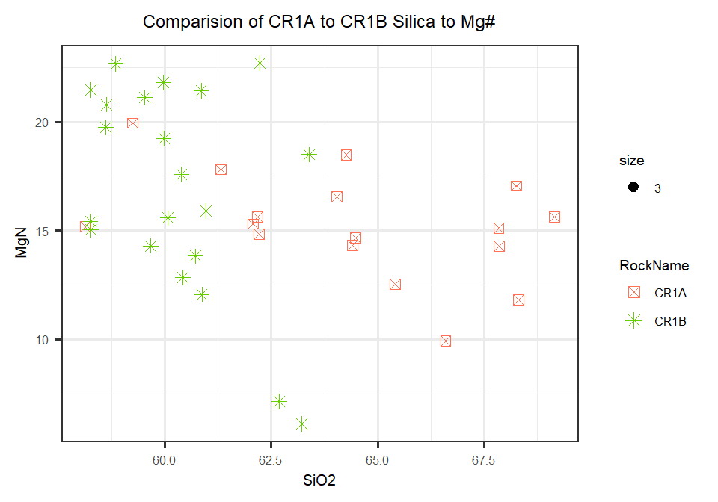

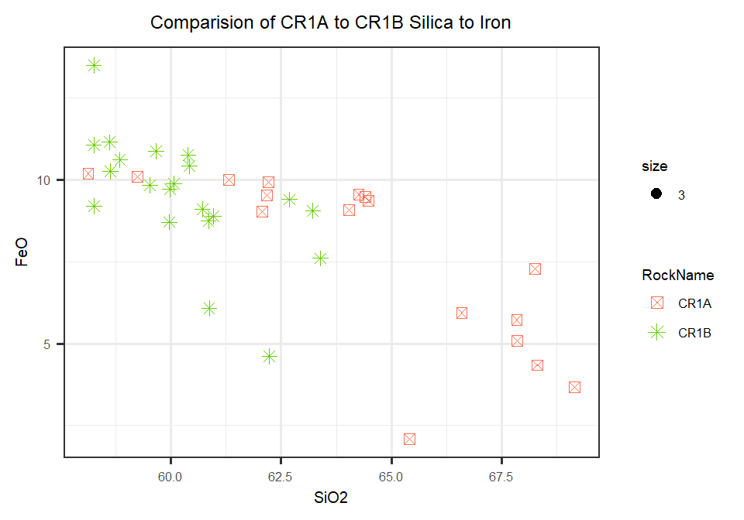

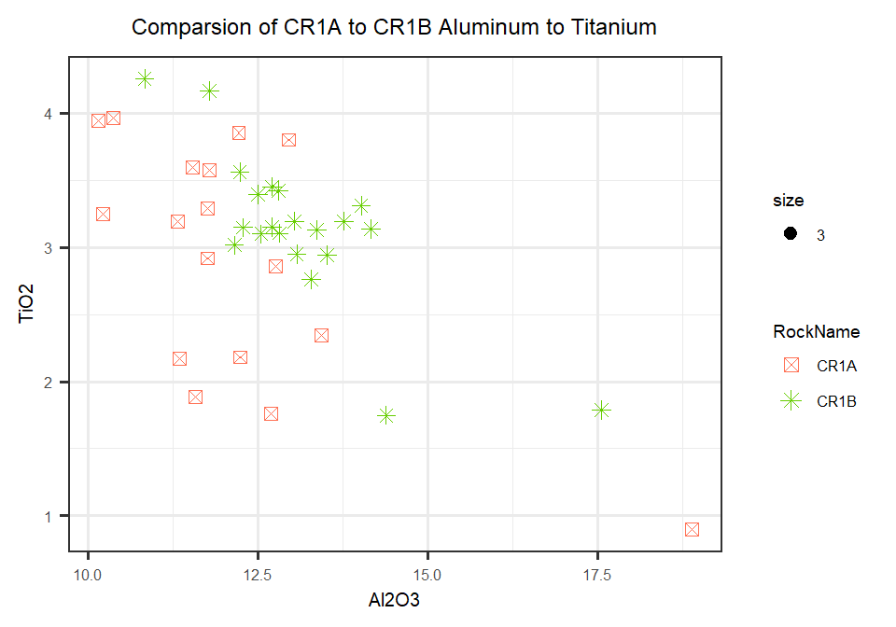

Taking a look at comparing CR2A to CR2B

